以下是我的修改需求：

1. 左侧的个人信息部分：头像，职位，单位，邮箱(原作者这里使用的@有点奇怪，这里可以直接使用@吗？)，CV/github/twitter的链接
（以上部分我都成功的更改成功了，但是你还是改一下，也许这里的更改会跟后面的更改产生链接）

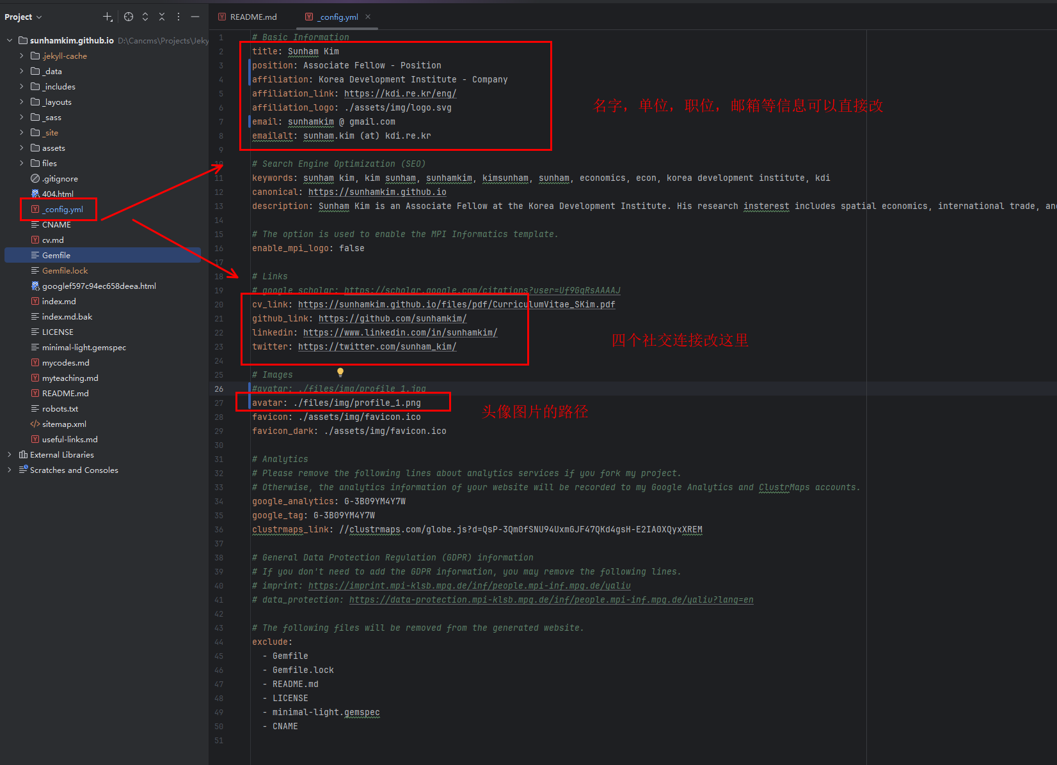

2. Banner的名字：这个部分是我一直搞不对的
第一：改变banner的名字 （注意banner的名字这里其实还可以点击，是一个回到主页的作用，我之前改了之后，没了这个banner名字还不好回主页）
第二：改一下banner的颜色 （随便改，告诉我在哪里改就好了）
第三：调整这个banner的宽度
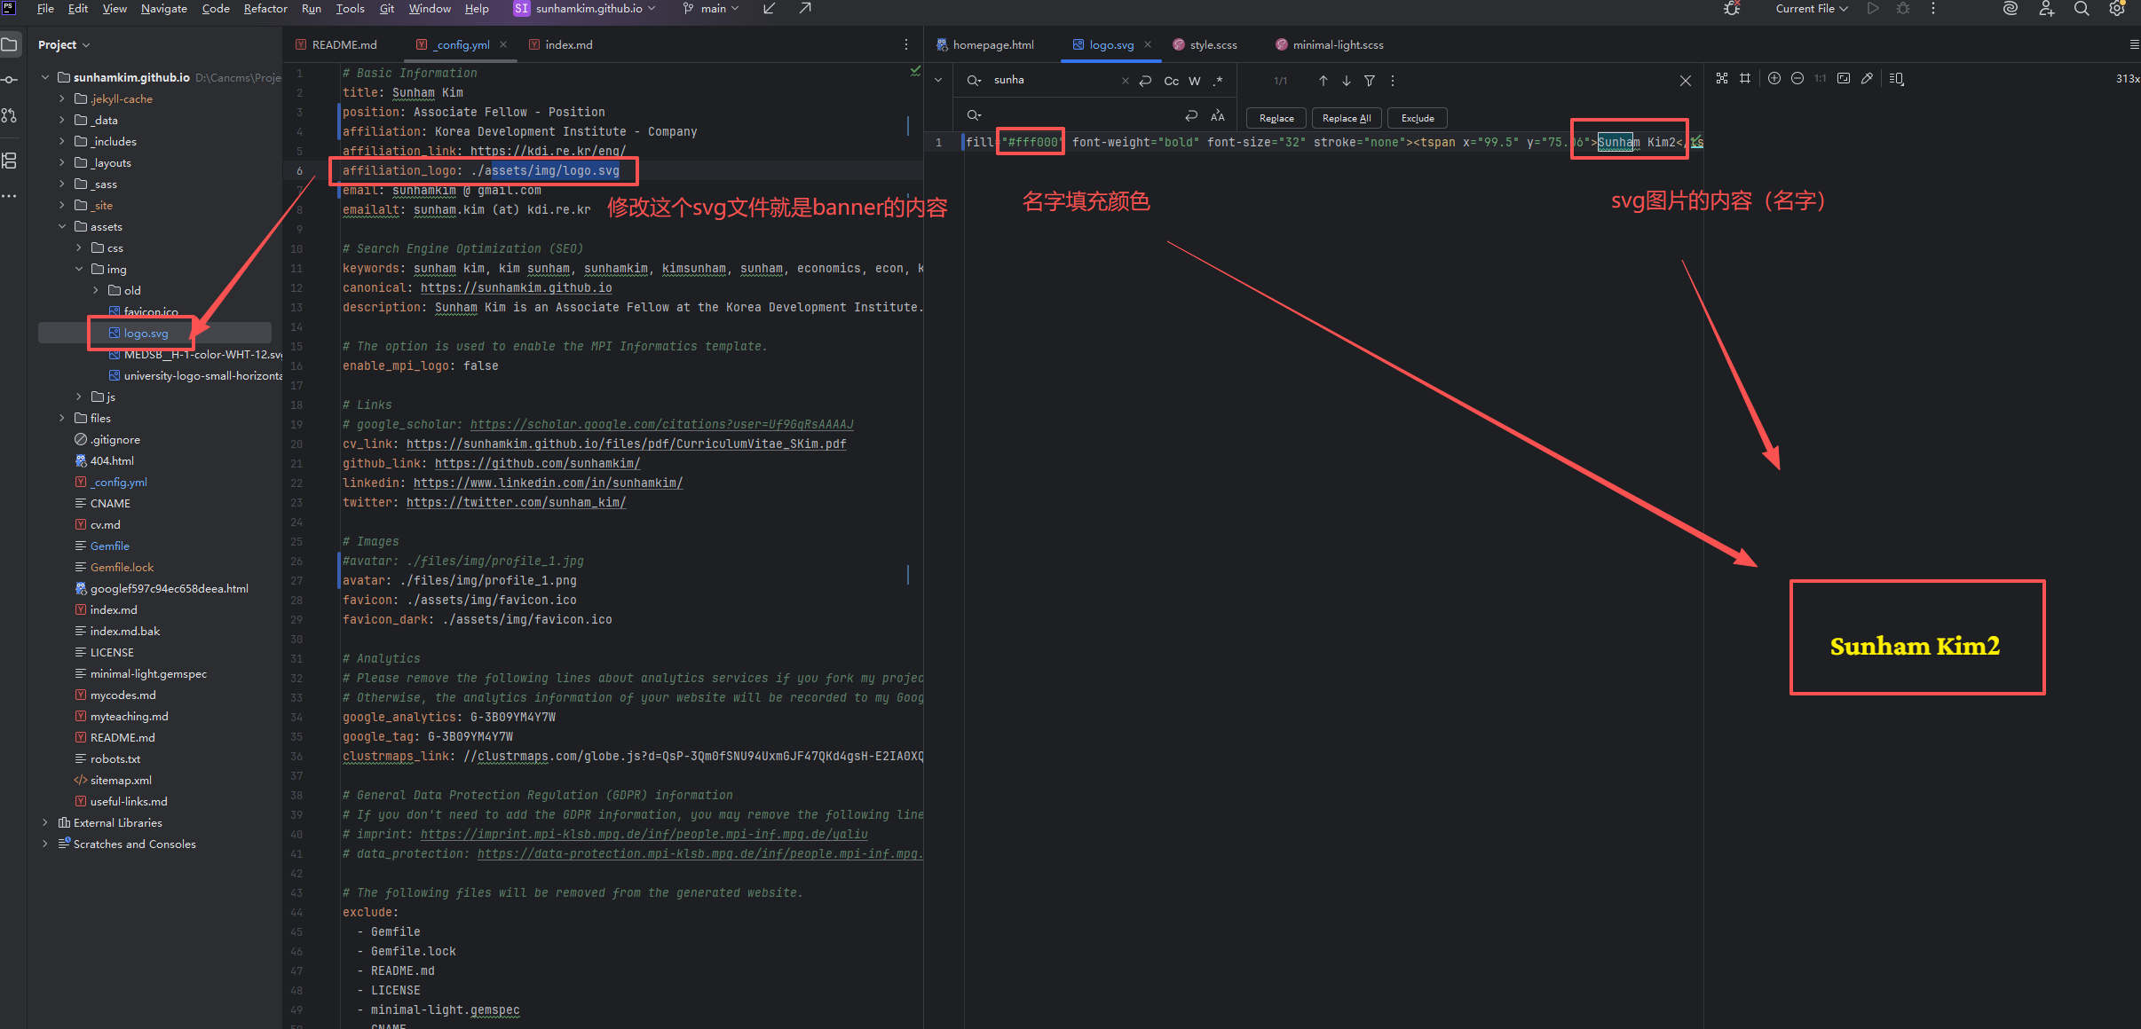
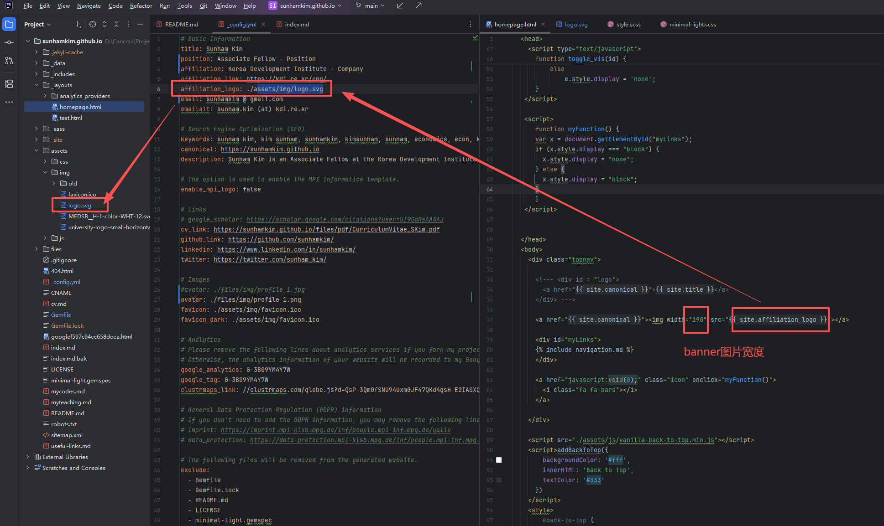
3. About Me 和 research interests 我也会改，你也随便改一改
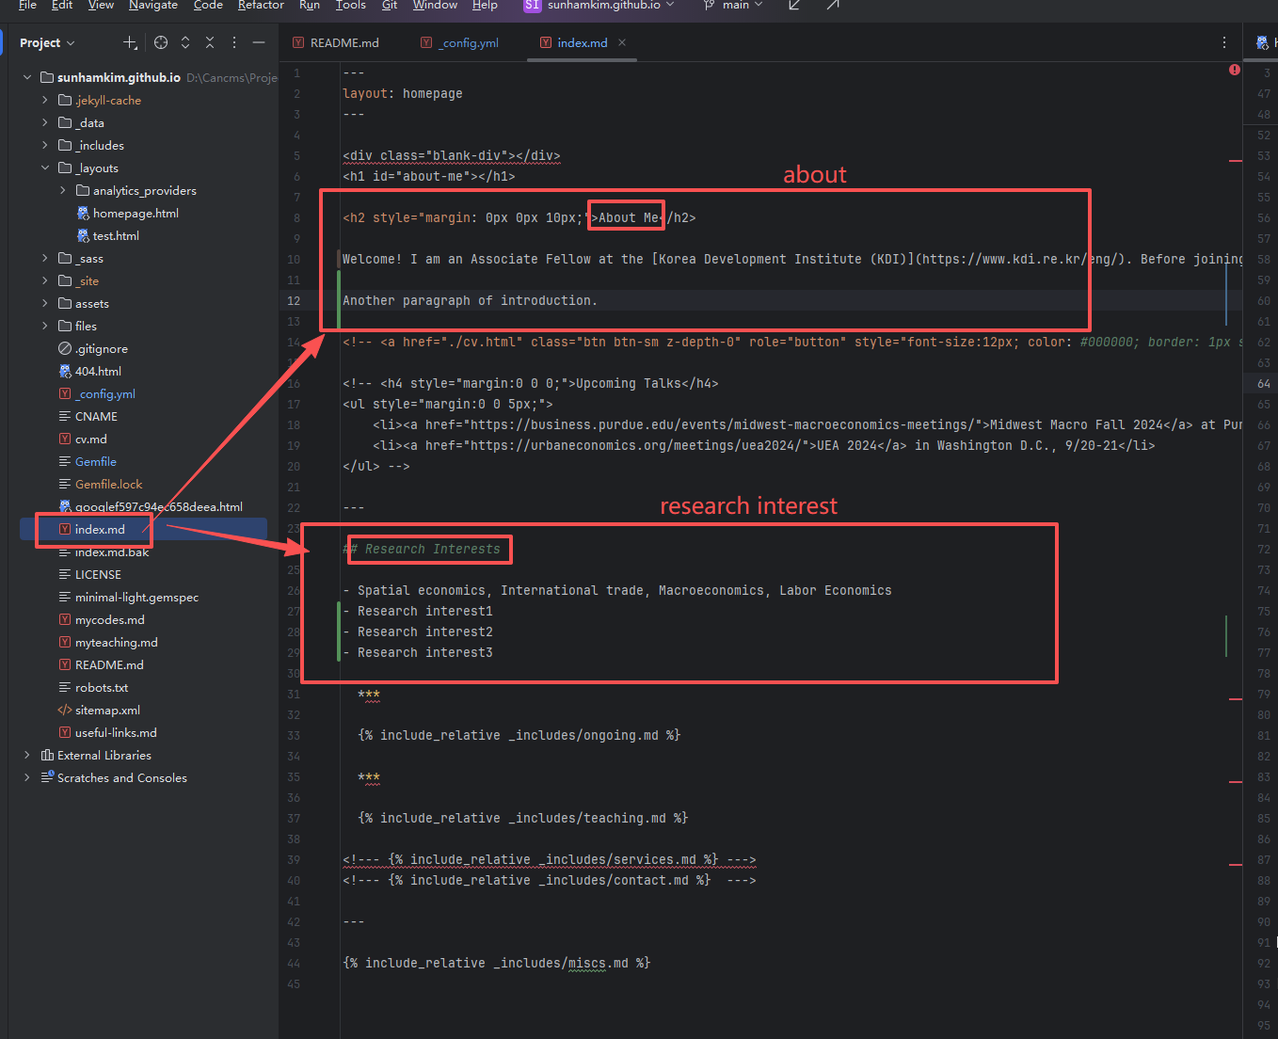
4. Working papers: 之前也是一直改不对，本来应该就是在ongoing 文档里面直接添加文字，但不知道为什么总是报错
尝试更改成下面这个文章：

Title: Gone with the Wind: dsadjkhajkdhkajdsbc (with Sunham Kim (添加网站 https://sunhamkim.github.io/))

Abstract: Air pollution disperses across political boundaries, yet many environmental policies regulate specific polluted locations. This paper studies how cross-boundary transport of fine particulate matter (PM2.5) changes the welfare effect and design of pollutant control policy in China. Using particle trajectory data from atmospheric transport models, we construct bilateral flow matrices that measure the transboundary air pollution in China. Three patterns emerge: (1) Transboundary pollution is heterogeneous across space, ranging from less than to over of local concentrations; (2) Bilateral pollutant transport networks remain stable over time, enabling long-term policy coordination without frequent recalibration; and (3) Economically developed provinces in China receive more transboundary pollution yet achieve larger pollution reduction. We develop a dynamic spatial general equilibrium model that incorporates pollutant transport, trade, and migration. Using this model, we estimate that transboundary air pollution creates a national welfare loss relative to a counterfactual where pollution remains local. We evaluate China's Air Pollution Prevention and Control Action Plan and compare it to alternative allocation rules. Reallocating abatement to high-spillover upwind provinces based on marginal social welfare of emission tax improves aggregate welfare by relative to the actual policy. The findings reveal welfare gains from accounting for spatial externalities in policy design.
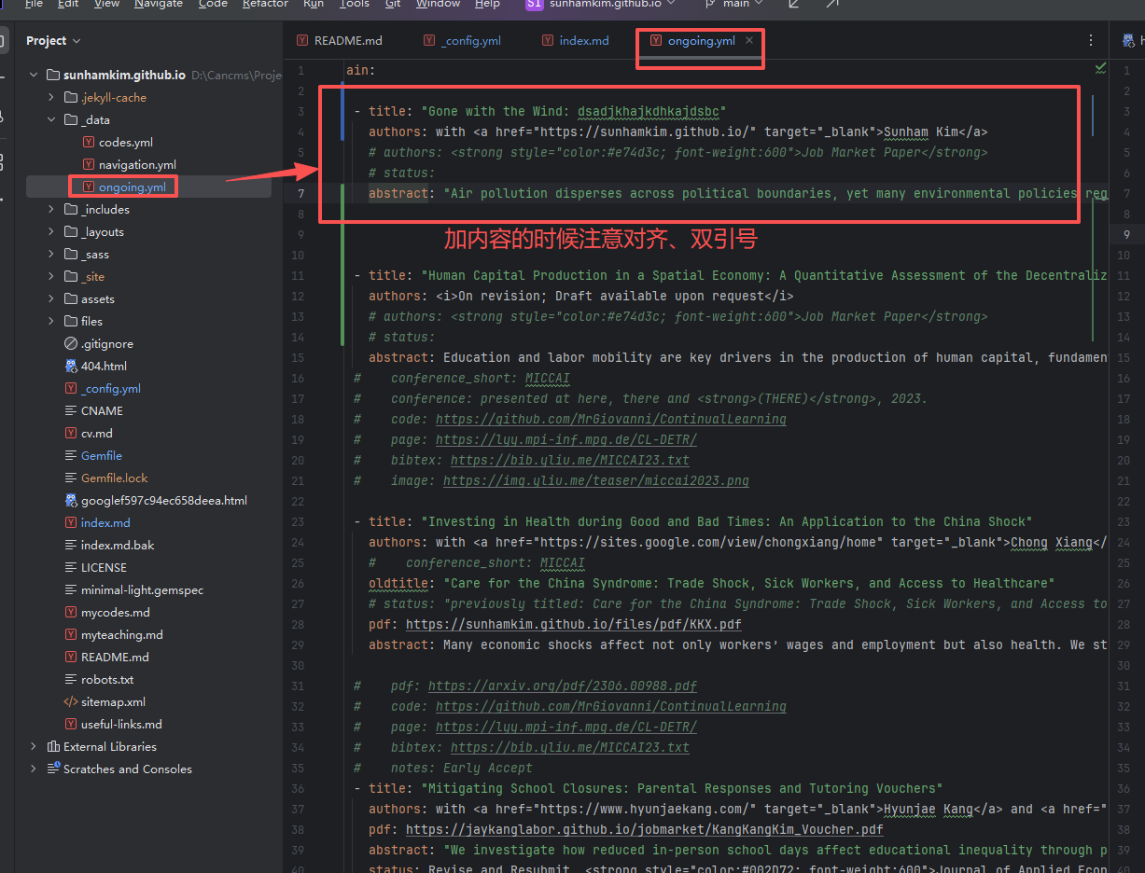
5. 删除CV这个section
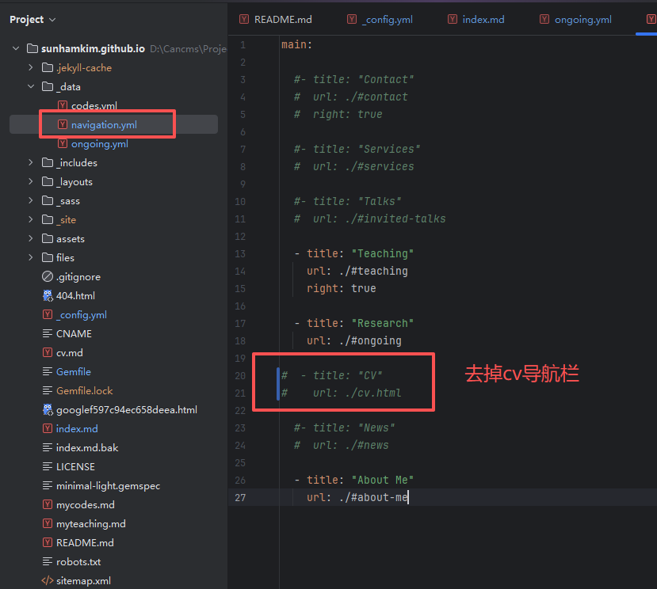

6. 在Wor king papers 下面添加一个publication，就跟working papers section是一样的 (每个文章下面有个 abstract 和 下载working paper的按钮)

就用上面这个例子：

Gone with the Wind: dsadjkhajkdhkajdsbc (with Sunham Kim (添加网站 https://sunhamkim.github.io/))

Journal of Development Economics, 2026, 119:2028

Abstract Working Paper
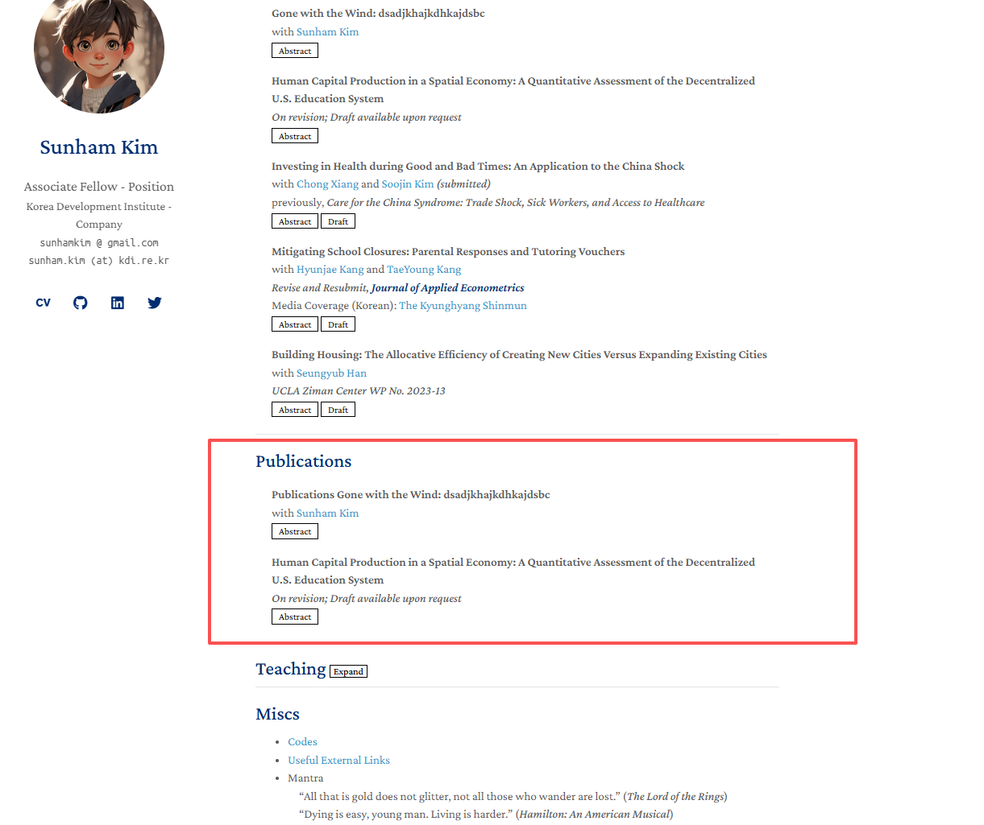
加了这个，具体你看git记录

7. 随便改一下teaching
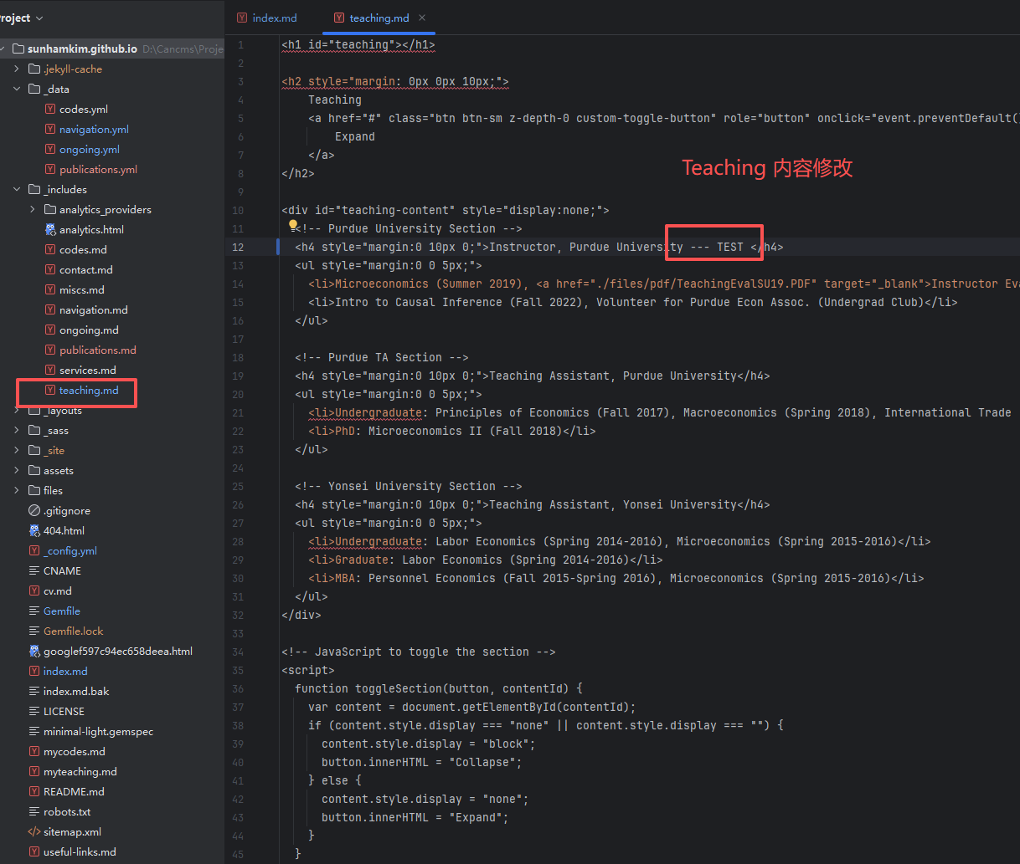
8. 随便在Useful externational Links里面添加一个新的内容
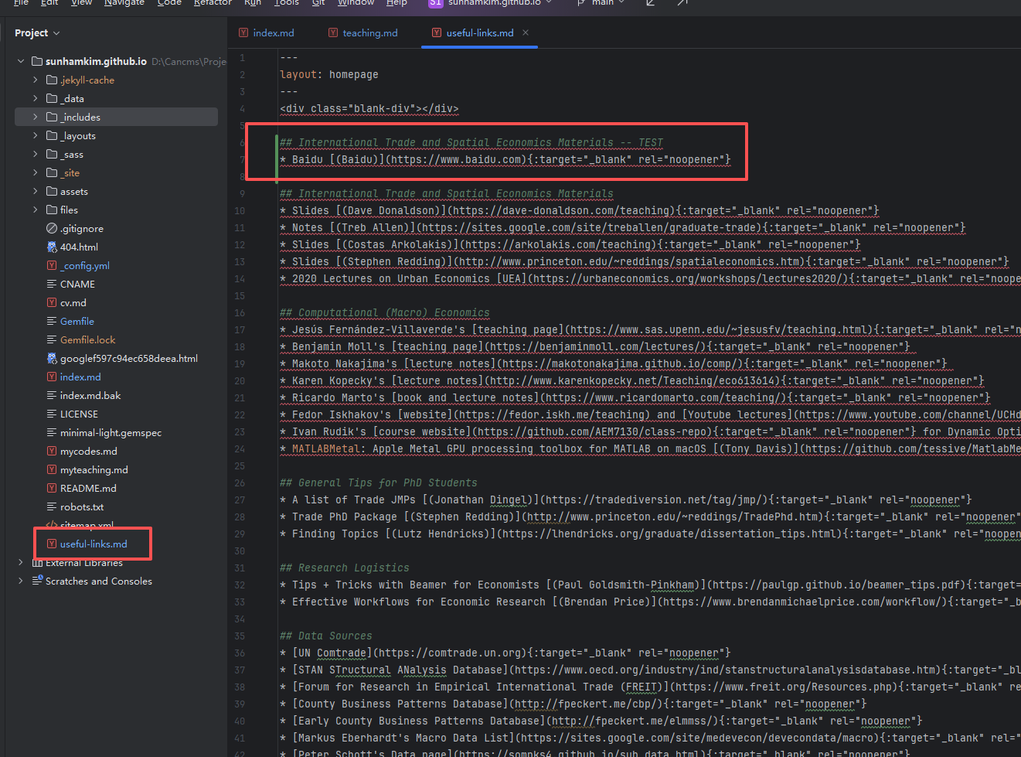

9. 整体的字体大小的缩放 和 字体的选择
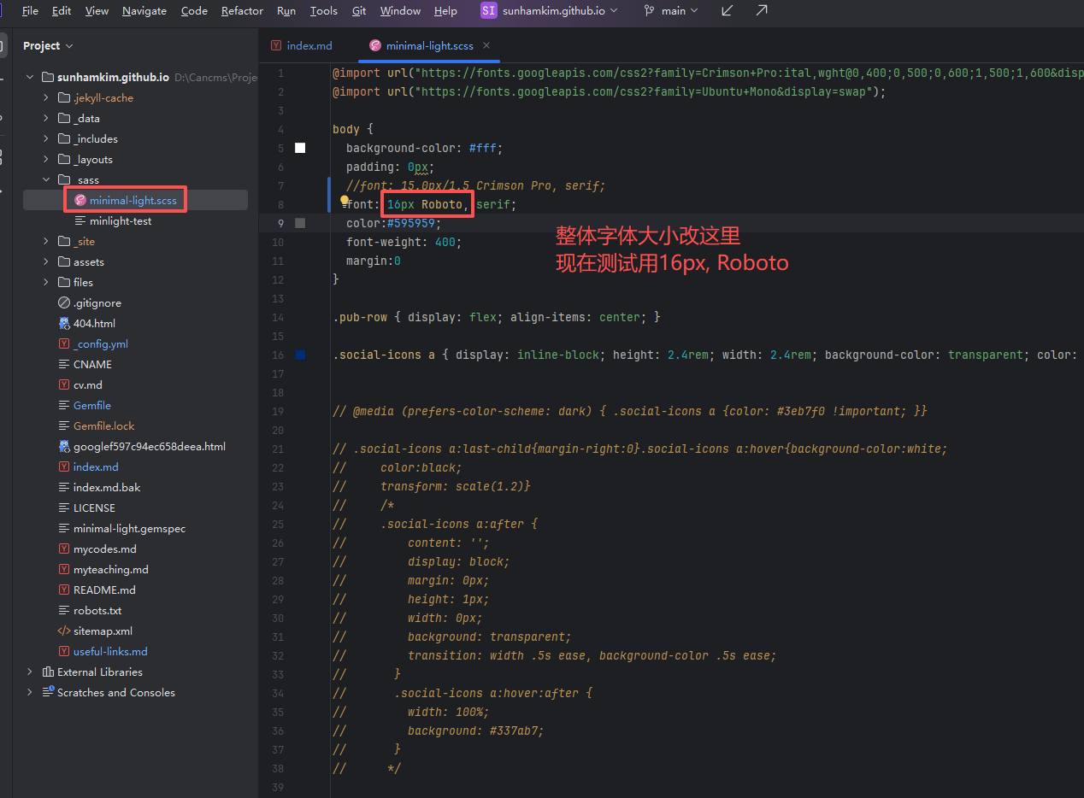
10．修改tab里面的图片
